**Supplementary Information**

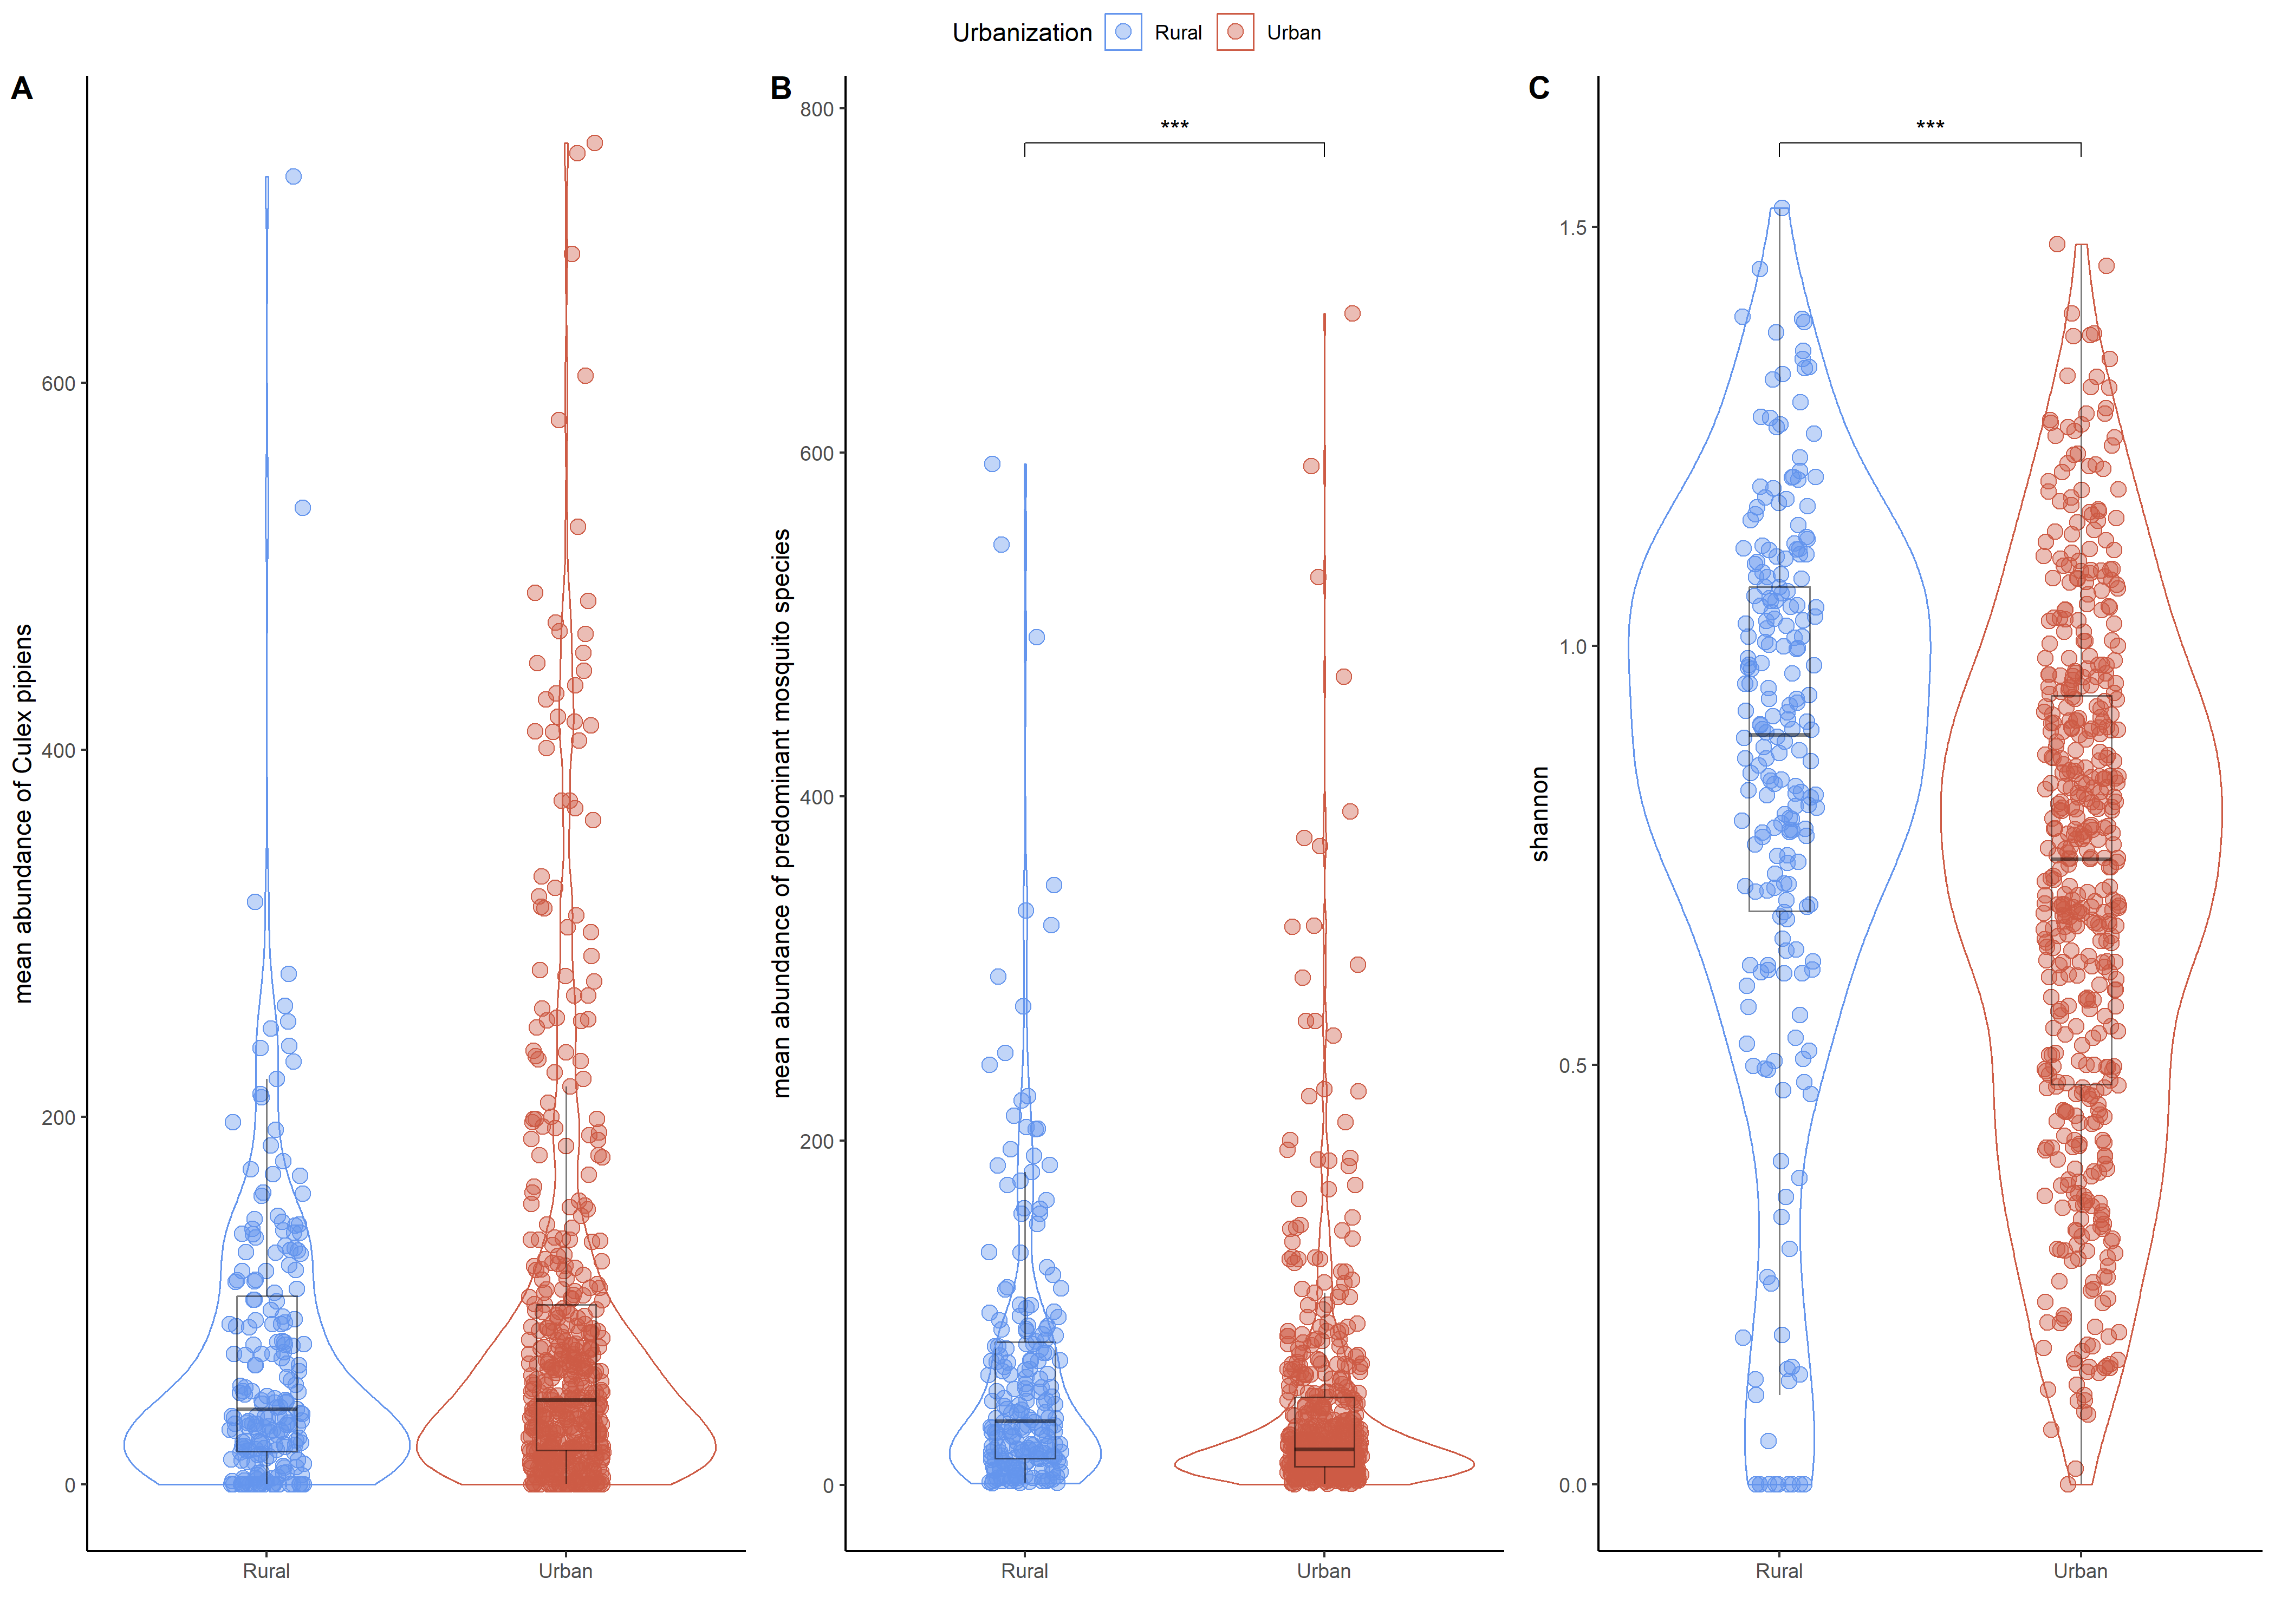

| S1 Fig. Abundance of mosquitoes and Shannon index of mosquito communities in urban and rural sites

Boxplots showing (A) the average abundance of *Culex pipiens* by site, month and year according to the level of urbanization. Boxplots showing (B) the average abundance and (C) the Shannon index of mosquito communities by site, month and year according to the level of urbanization. The mosquito communities were composed of the predominant species in the dataset (*Culex pipiens*, *Culex modestus*, *Aedes vexans*, *Aedes detritus*, *Ochlerotatus caspius*, *Anopheles hyrcanus*). Blue dots represent urban sites, while red dots represent rural sites. A greater abundance of predominant mosquito species was detected in urban environments than in rural ones (Wilcoxon test p-value < 0.001).

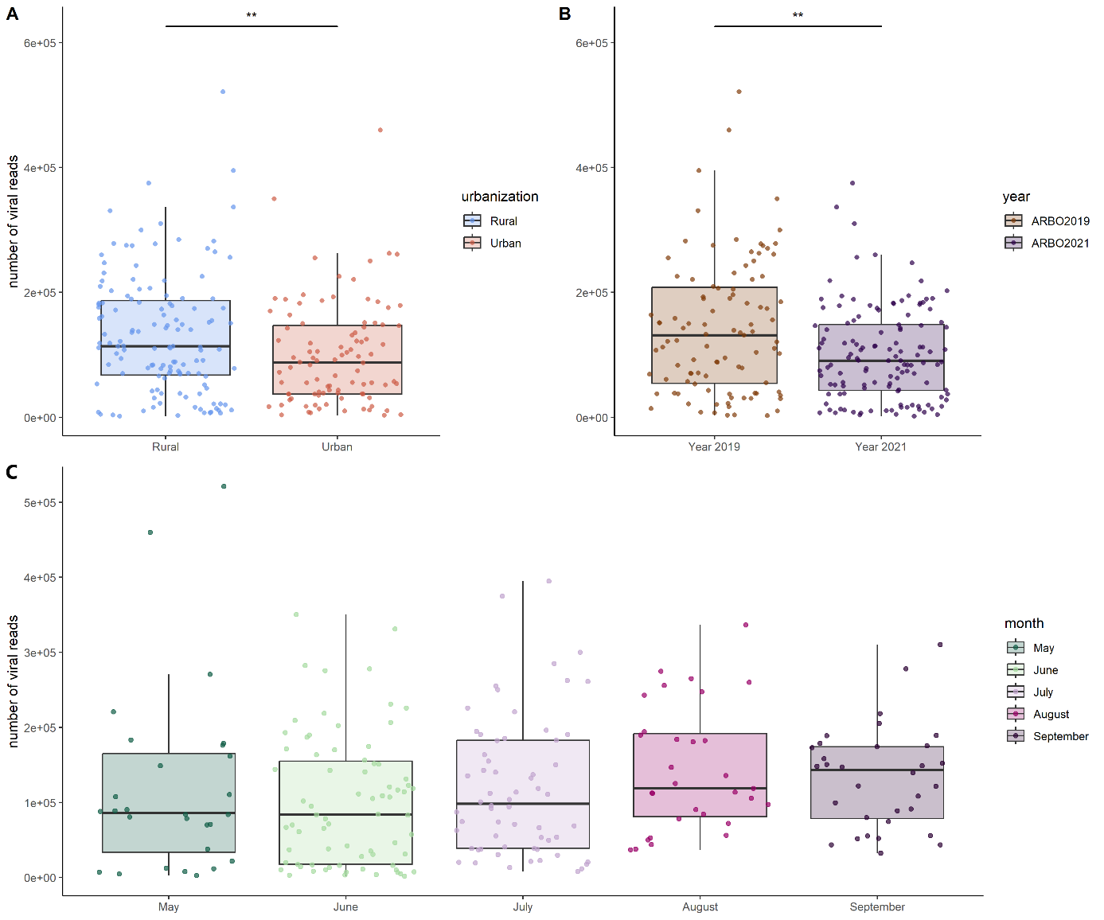

| S2 Fig. Distribution of viral reads by (A) urbanization level, (B) year and (C) month

The bar above the boxplots for each panel represents the value and degree of significance between the different groups, according to the wilcoxon test values. Significance codes: 0 '***', 0.001 '**', 0.01 '*', 0.05 '.', 0.1 ''.

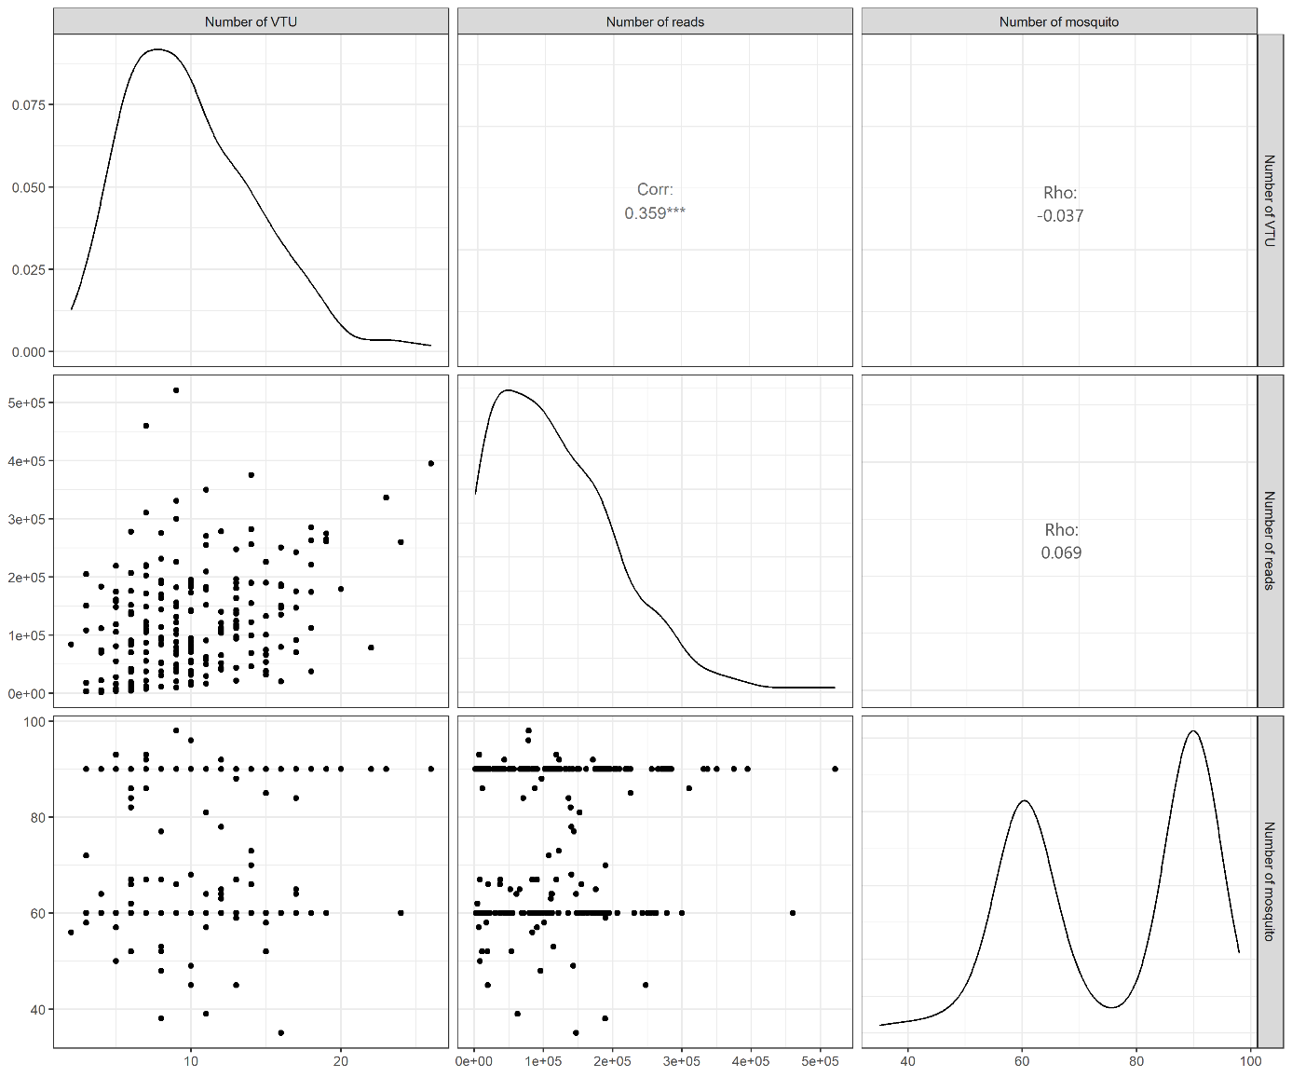

| S3 Fig.

Plot matrix showing graphs and correlation values between the number of VTUs, the number of viral reads and the number of mosquitoes in the pool. Each of these variables is compared two by two in the graph, and the correlation results are found at the intersection between a given pair of variables.

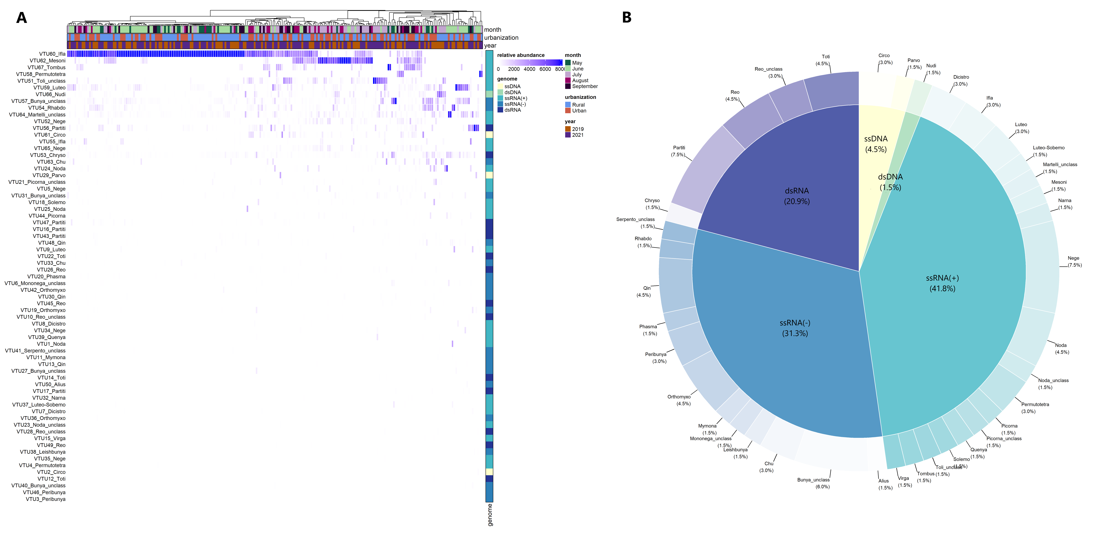

| S4 Fig. Distribution of viral taxonomic units (VTUs) among family-like clusters (external donut chart) and type of genome based on Baltimore classification (inner pie chart).

Percentages between brackets represent the proportion of VTUs in each group.

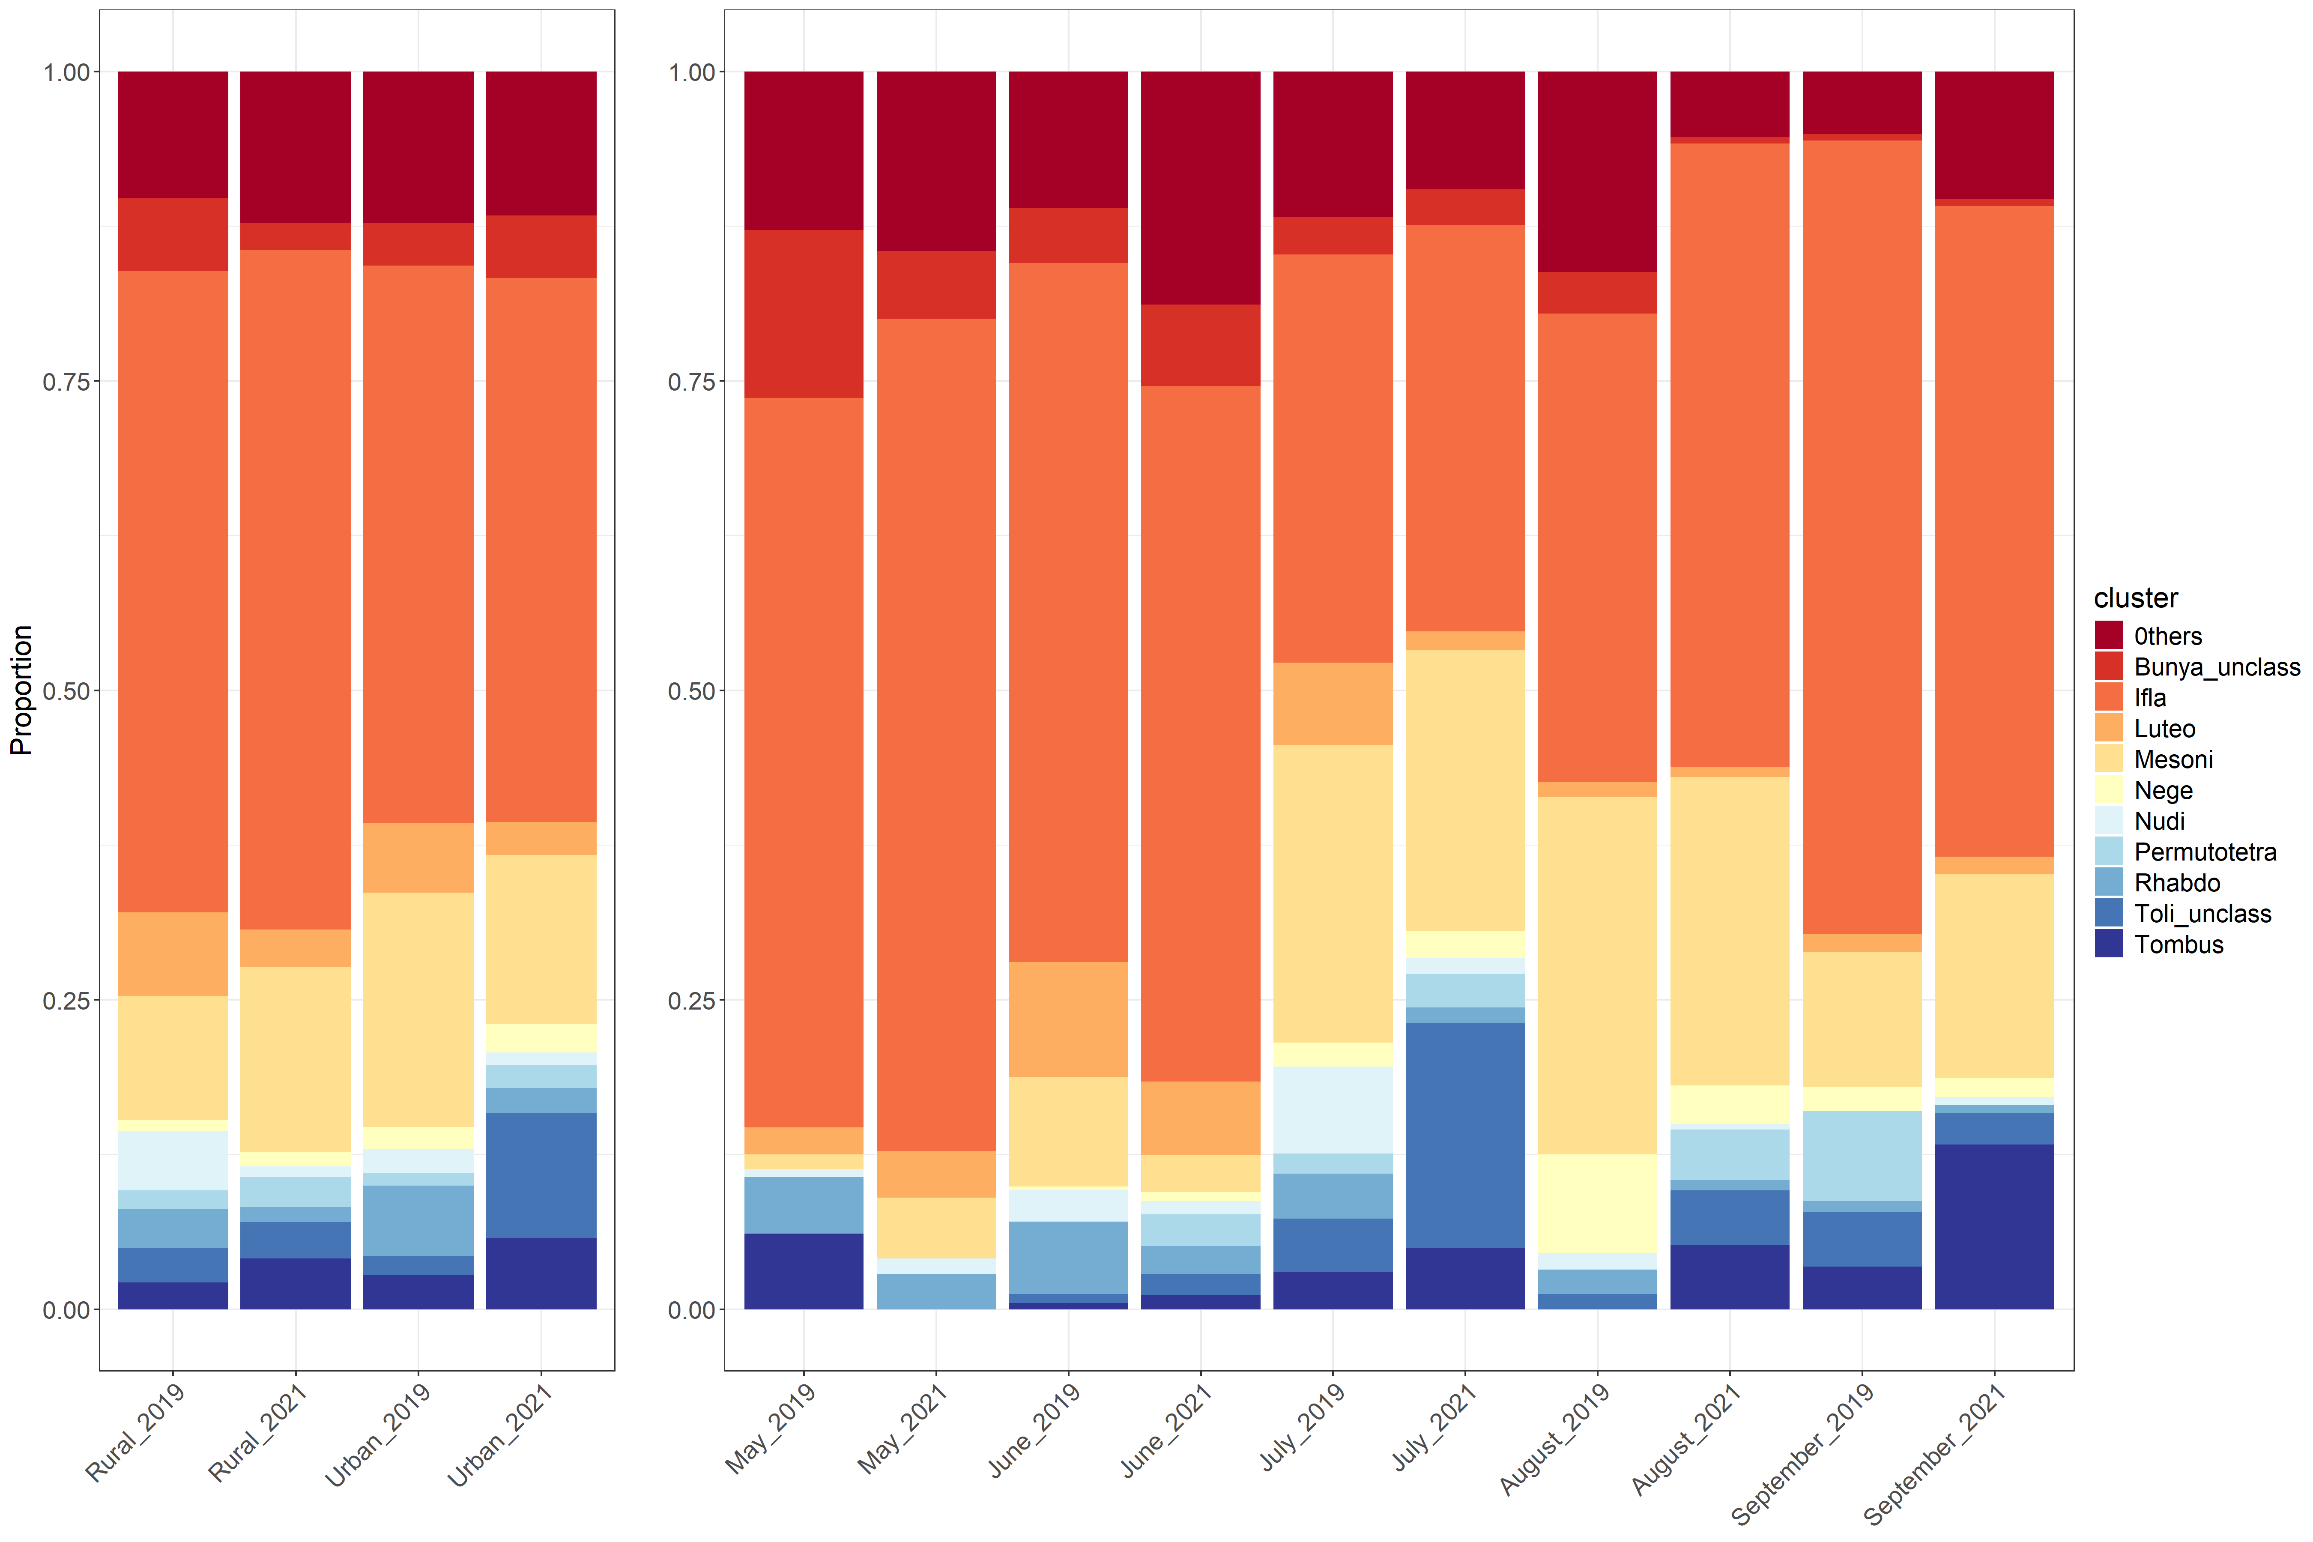

| S5 Fig. Mean relative abundance of the ten most abundant clusters

The bar plots represent the mean relative abundance of the ten most abundant clusters in our dataset, by level of urbanization and year (left) and by month and year (right). The relative abundance of all other clusters is shown in dark red (classified as "Others").

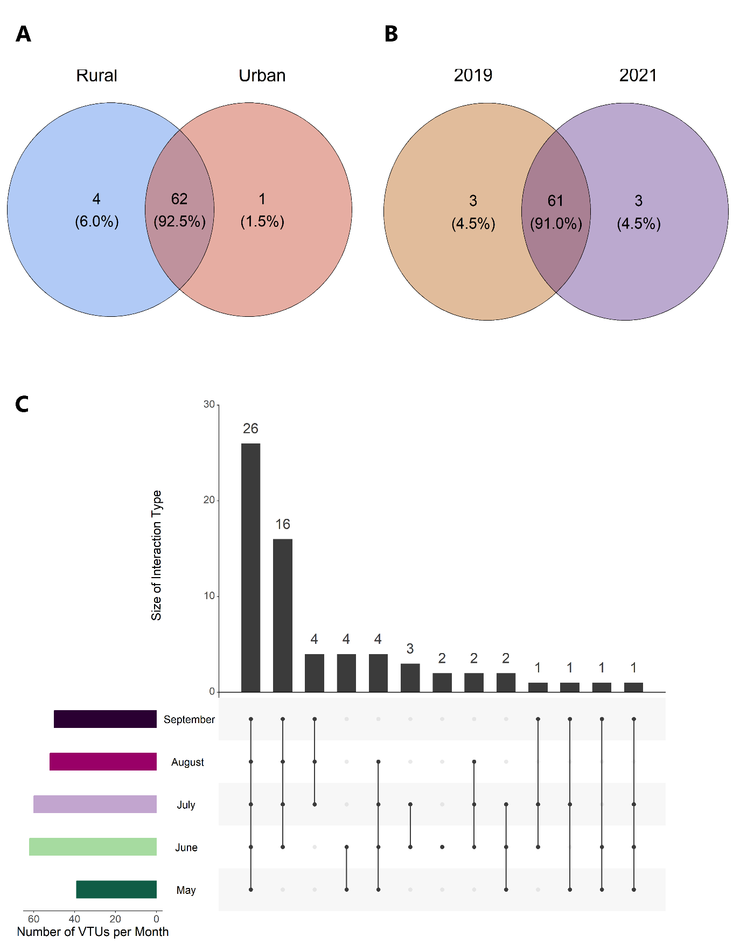

| S6 Fig. Presence-absence of viral taxonomic units (VTUs) among libraries and different factors

The presence of VTUs is divided into the following categories: Venn diagram separated by (A) urbanisation and (B) year. The numbers in brackets represent the proportion of each group in relation to the total number of VTUs (C) The upset diagram shows the presence of VTUs in each month. The black dots indicate the presence of VTUs in a given month and vertical bars link moths with VTU presence. The number above each bar corresponds to the number of VTUs in each category. The coloured horizontal bars to the left of the list of months indicate the number of VTUs per month.

| S1 Table. Sampling sites of the study.

The name of the site is given in the “Site” column. The EID agency responsible for the captures is indicated in the “Agency” column. The other columns describe the site in the following order (from left to right): the distance to the first dwelling, the town in which the site is located, the number of inhabitants of the town in 2019, the latitude and the longitude. The “Urban”, “Cropland” and “Natural_Semi-natural” columns were used for classifications according to the level of urbanisation. The values for each site represent the number of “pixels” of 1 km2 belonging to the group in question. Depending on the proportion of each group (see Materials and Methods), the sites were classified as urban or rural, indicated in the “Urbanization_level” column.

<https://github.com/ComeMorel/Thesis/blob/main/Chapter%201%3A%20Temporal%20structure%20in%20the%20mosquito%20virome/Table_S1.csv>.

| S2 Table. Output of the sequencing and the bioinformatics analysis.

Library names are shown in the “Pool” column. Library names have been generated to include the main study variables: year of collection, month, urbanization level, site, agency and replicas. The “pipiens_number” column indicates the number of culex pipiens mosquitoes grouped in the library. The other columns represent the output of the bioinformatics pipeline, with the number of total reads (“Total_read”), the number of reads with a viral hit (“Reads_with_viral_hit”), the proportion of viral reads (%_viral_reads), the number of reads mapped to Diptera (“Map_on_Diptera”) or bacteria (“Map_on_Bacteria”), the number of contigs (“Nb_of_contigs”), contig size information (“Min_contigs_length”, “Max_contigs_length”, “Avg_contigs_length”) and the number of contigs with a viral hit (“Contigs_with_viral_hit”).

<https://github.com/ComeMorel/Thesis/blob/main/Chapter%201%3A%20Temporal%20structure%20in%20the%20mosquito%20virome/Table_S2.csv>.

| S3 Table. Read count by VTU and taxonomy.

The "VTU" column provides the name given to the VTU. The "Best-hit" column provides the accession with the lowest e-value found by Diamond. The "Nucleic_acid" and "genome" columns provide information on the type of VTU genome. The "cluster" column was created to add a taxonomic rank similar to a family, in order to avoid the lack of taxonomic information for certain viruses. The "clade" to "genus" columns provide the VTU taxonomy as stated by the ICTV. All columns from "qlen" to "bitscore" provide information on the contigs of each VTU and are Blastn output. All other columns represent count data by libraries for each VTU. The "sum_reads" column provides information on the total number of reads detected for the VTU (across all libraries).

<https://github.com/ComeMorel/Thesis/blob/main/Chapter%201%3A%20Temporal%20structure%20in%20the%20mosquito%20virome/Table_S3.csv>.

| S4 Table. Output statistics of Generalized Linear Mixed models.

The upper table shows the results of the model using the “glmmTMB” function implemented in R. The columns represent the statistical results for each variable tested: “Urbanization”, “Month” and “Year”. Each row represents a diversity index: “Species richness”, “Shannon” and “Simpson”.

The lower table shows the results of pairwise comparisons, obtained using the emmeans function for each diversity index (in columns). The following significance codes are used to indicate the level of statistical significance: 0, '***', 0.001, '**', 0.01, '*', 0.05, '.' and 1.

<https://github.com/ComeMorel/Thesis/blob/main/Chapter%201%3A%20Temporal%20structure%20in%20the%20mosquito%20virome/Table_S4.csv>.

| S5 Table. Output of the SBM model for samples.

Pool names are shown in the ‘Pool’ column. The ‘Month’, ‘Year’ and ‘Urbanization_level’ columns show the month, year and urbanization level associated with each pool. The ‘sample_blocks’ column represents the sample blocks created by the ‘Stochastic block model’ and associated with each pool.

<https://github.com/ComeMorel/Thesis/blob/main/Chapter%201%3A%20Temporal%20structure%20in%20the%20mosquito%20virome/Table_S5.csv>.

| S6 Table. Output of the SBM model for VTUs.

The names of the virus blocks are entered in the “Virus blocks” column. The names of the VTUs in each group are listed in the “VTUs” column. The viral families associated with the VTUs in each virus block are described in the “Virus families” column.

<https://github.com/ComeMorel/Thesis/blob/main/Chapter%201%3A%20Temporal%20structure%20in%20the%20mosquito%20virome/Table_S6.csv>.

| S7 Table. Output statistics of Canonical Correspondence analysis model.

Results of canonical correspondence analysis applied to the entire network to explain viral communities using month of capture, level of urbanization of the site and year of capture. Explanatory and conditional effects (indicated by the term “Condition()”) are shown in the “Formulas” column. The values of the corresponding chi-square statistic are shown in the “chi2” column. The values of the F statistic are shown in the “F” column. The column P represent the p-values.

<https://github.com/ComeMorel/Thesis/blob/main/Chapter%201%3A%20Temporal%20structure%20in%20the%20mosquito%20virome/Table_S7.csv>.